Mining Form Update
- In Question number 5 in mine list Coal added here.
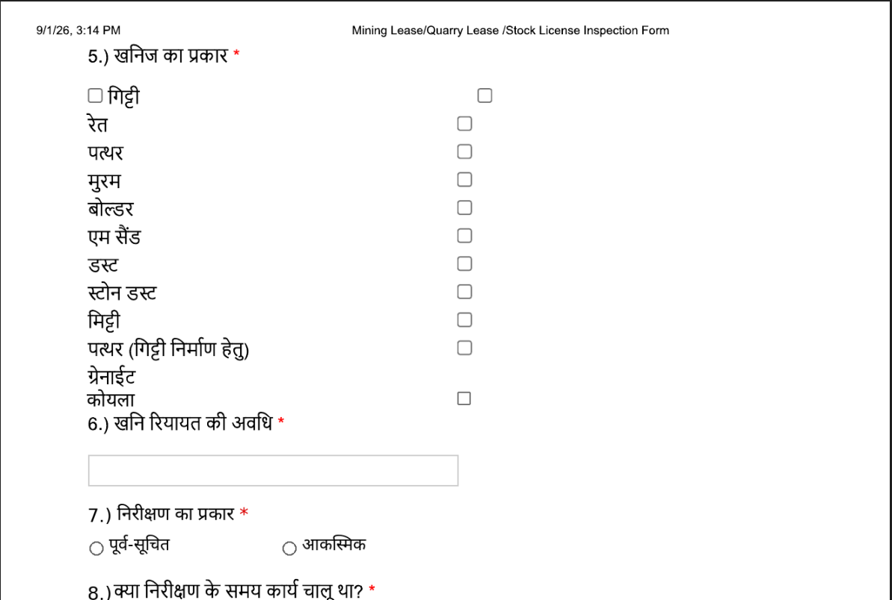
- after the question about “ खनी रियात की अवधि” added a question “निरीक्षण का प्रकार”.
- If one selects the options “no” for that a question is porposed here.
